**Practical 8: Implementing “Big” Web Service.**

**1. Creating a Web Service**

**A. Choosing a Container:** Open NetBeans IDE 8.2

1. Choose File > New Project. Select Web Application from the Java Web.

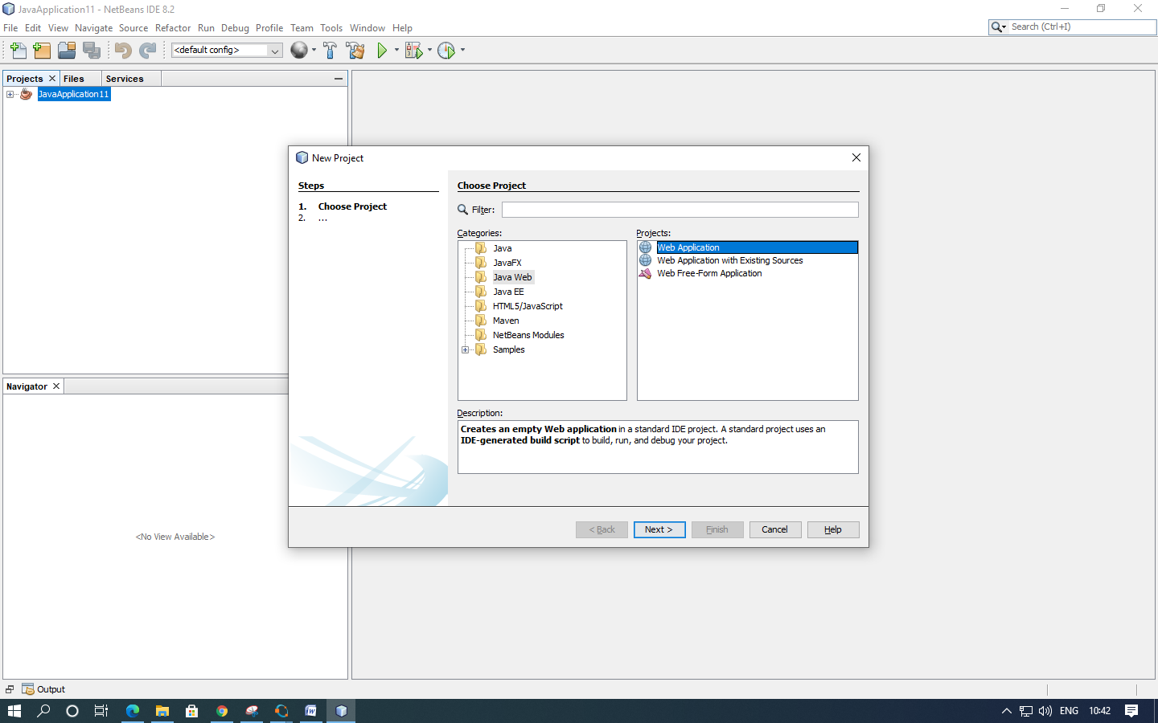

2. Name the project “CalculatorWebService”. Select a location for the project. Click Next.

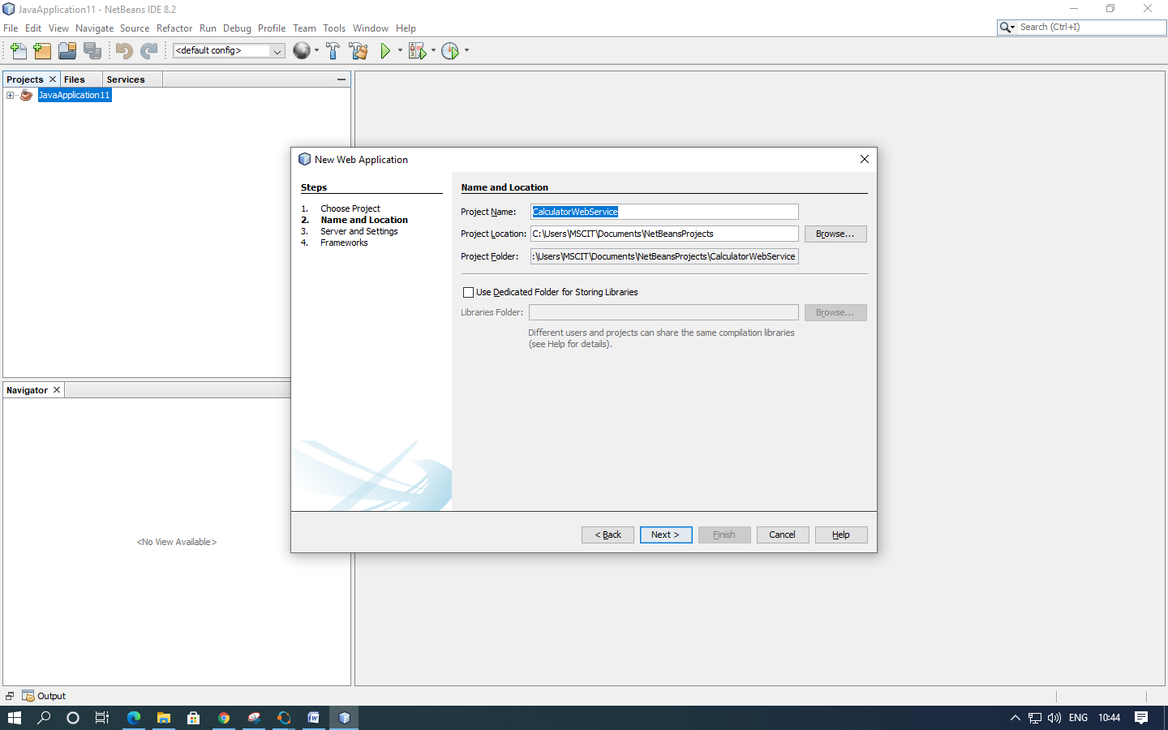

3. Select your server and Java EE version and click Finish. (Do not do anything in Framework)

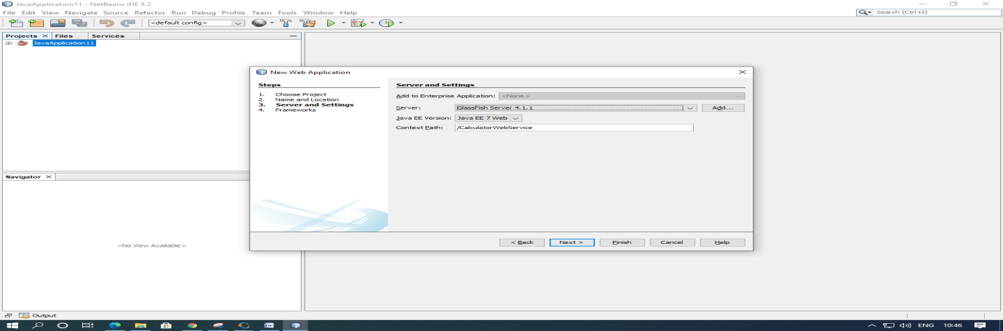

**B. Creating a Web Service from a Java Class**

1. Right-click the “CalculatorWebService” node and choose New > Web Service.

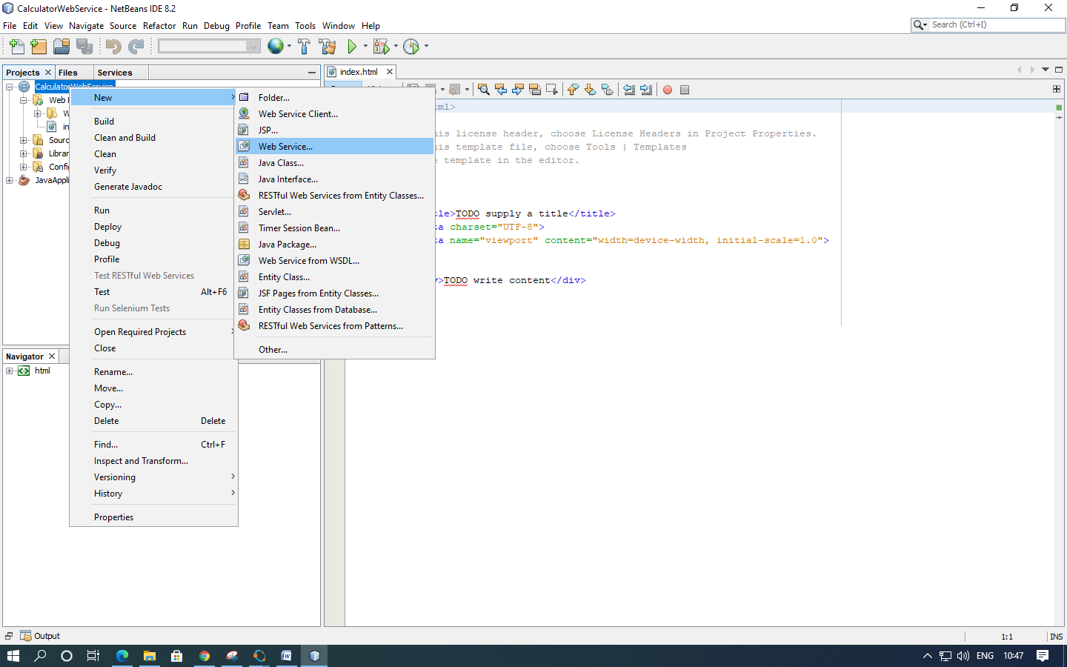

1. Name the web service “CalculatorWeb” and type org.me.calculator in Package. Leave Create Web Service from Scratch selected.

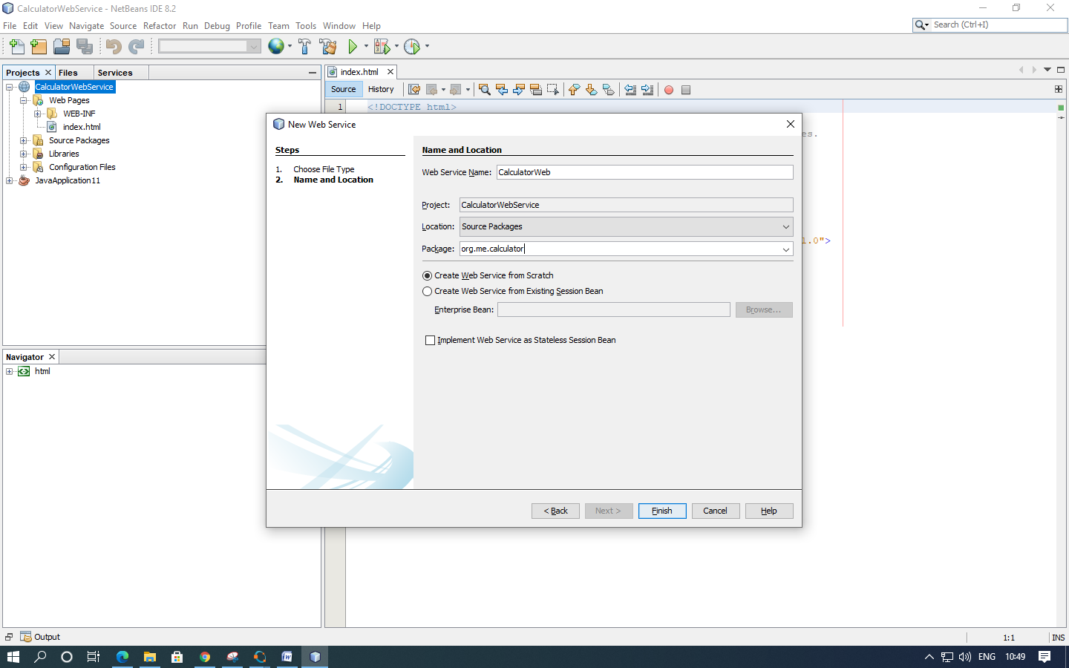

3. Click Finish. The Projects window displays the structure of the new web service and the source code is shown in the editor area.

**2. Adding an Operation to the Web Service :**

The goal of this exercise is to add to the web service an operation that adds two numbers received from a client. The NetBeans IDE provides a dialog for adding an operation to a web service. You can open this dialog either in the web service visual designer or in the web service context menu.

**A. To add an operation to the web service:**

1. Change to the Design view in the editor.

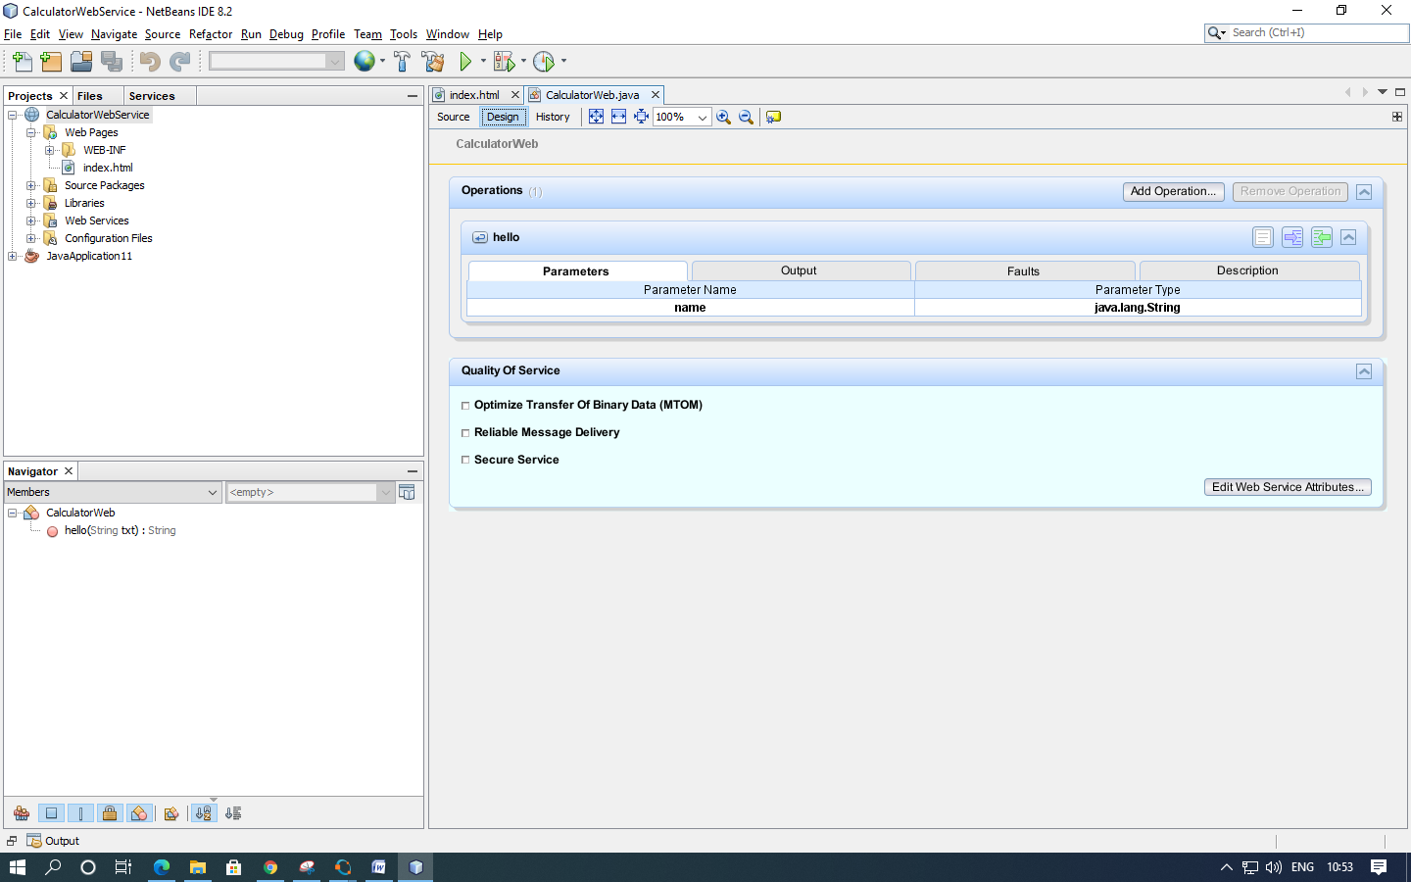

2. Click Add Operation in either the visual designer or the context menu. The Add Operation dialog opens.

3. In the upper part of the Add Operation dialog box, type add in Name and type int in the Return Type drop-down list.

4. In the lower part of the Add Operation dialog box, click Add and create a parameter of type int named i.

5. Click Add again and create a parameter of type int called j. You now see the following:

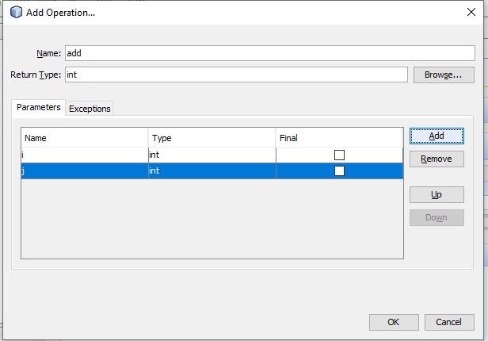

6. Click OK at the bottom of the Add Operation dialog box. You return to the editor.

7. The visual designer now displays the following:

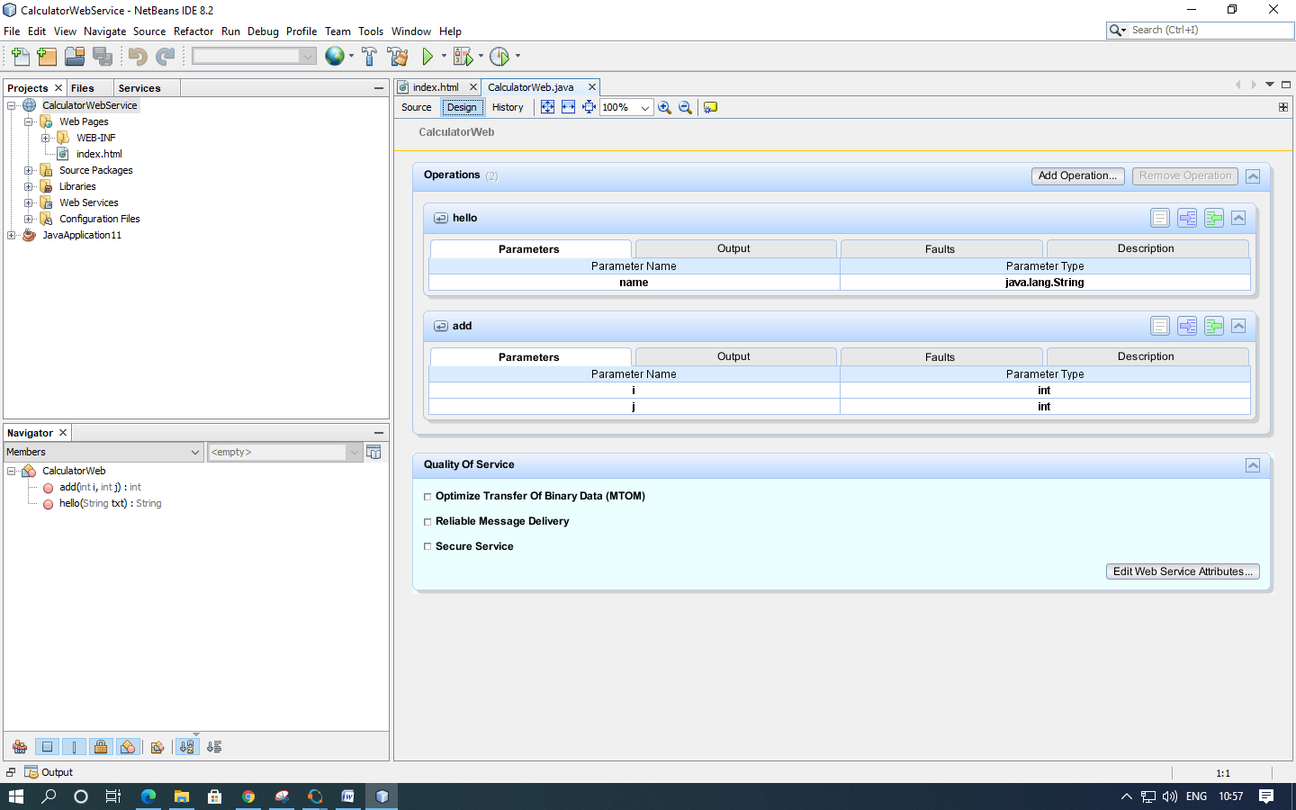

8. Click Source. And code the following.

@WebMethod(operationName = "add")

public int add(@WebParam(name = "i") int i, @WebParam(name = "j") int j) {

int k = i + j;

return k;

}

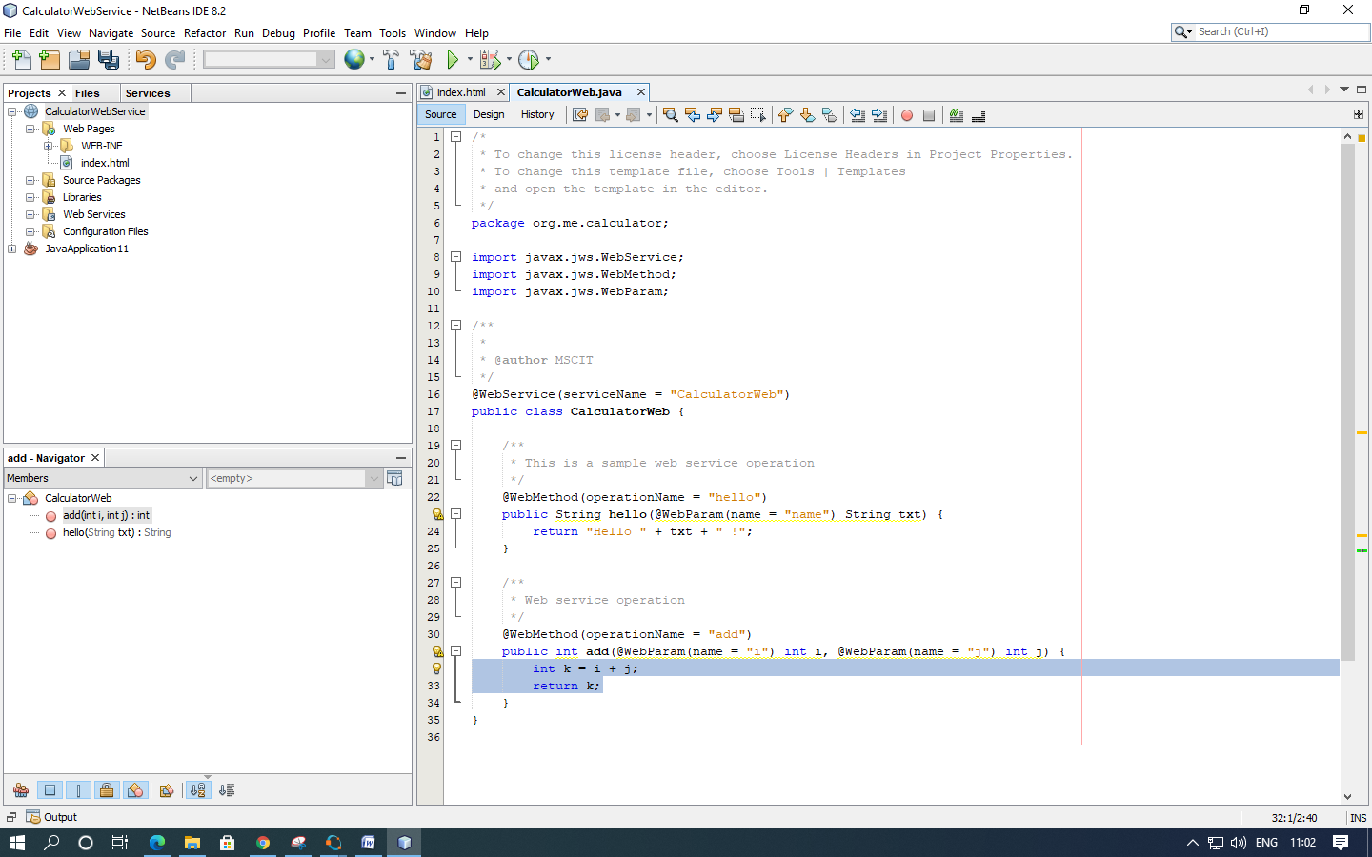

**3. Deploying and Testing the Web Service:**

After you deploy a web service to a server, you can use the IDE to open the server's test client, if the server has a test client. The GlassFish and WebLogic servers provide test clients.

**A. To test successful deployment to a GlassFish or WebLogic server:**

1. Right-click the project and choose Deploy. The IDE starts the application server, builds the application, and deploys the application to the server

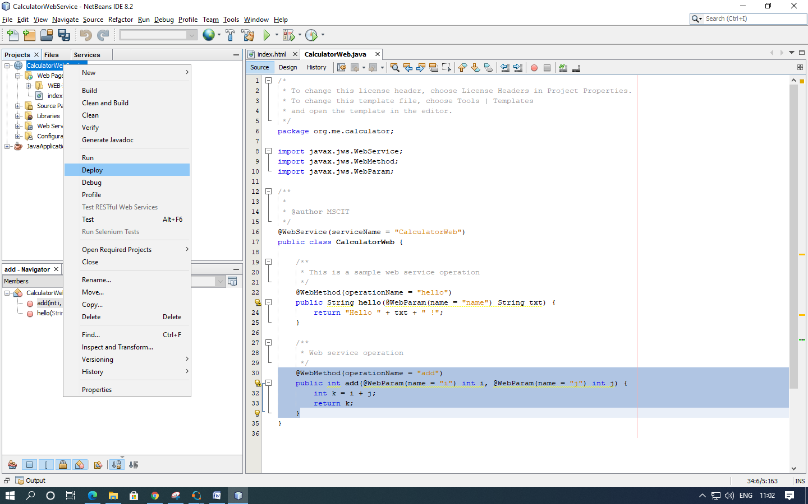

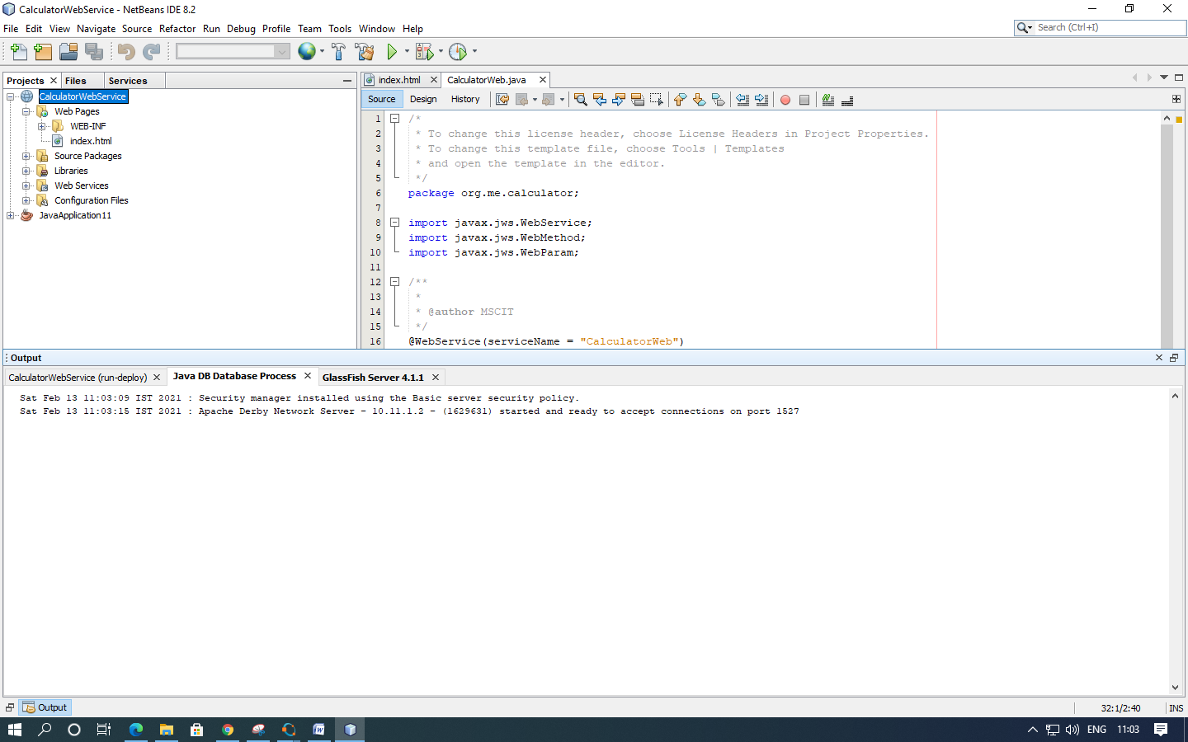

2. In the IDE's Projects tab, expand the Web Services node of the “CalculatorWebService” project. Right-click the “CalculatorWeb” node, and choose Test Web Service.

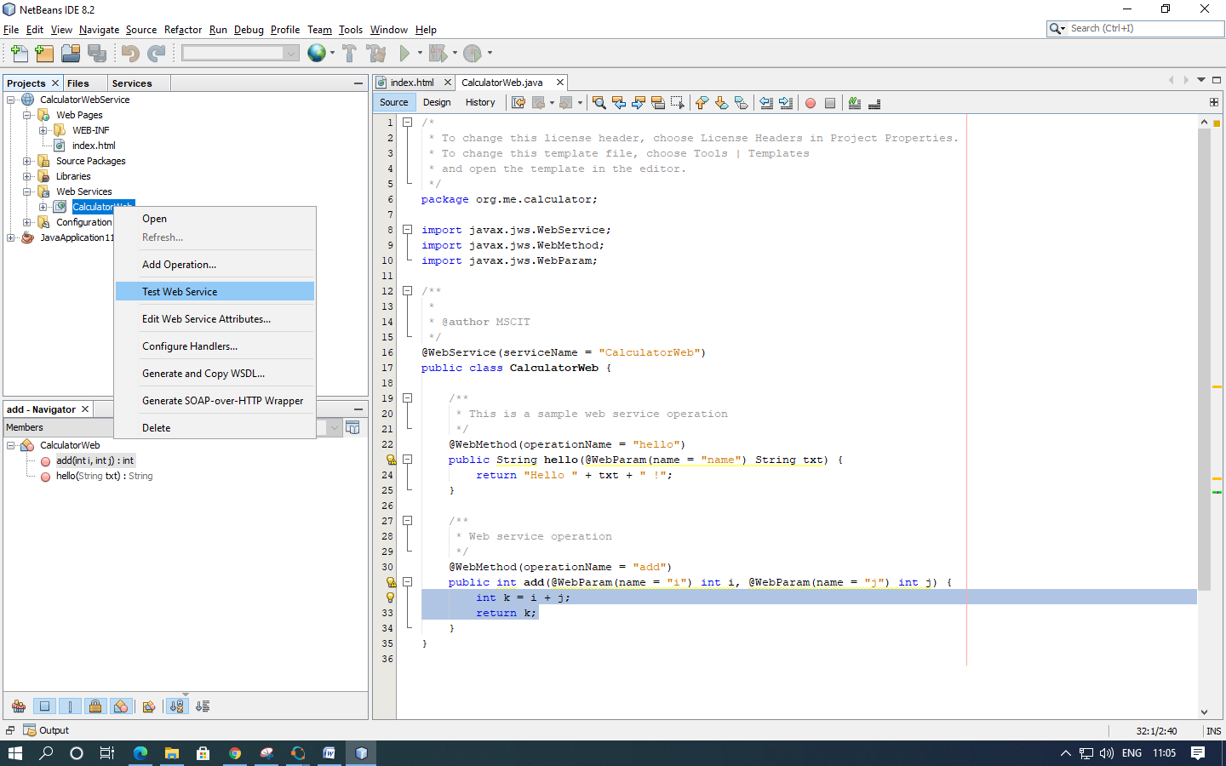

3. The IDE opens the tester page in your browser, if you deployed a web application to the GlassFish server.

4. If you deployed to the GlassFish server, type two numbers in the tester page, as shown below and press enter for output.

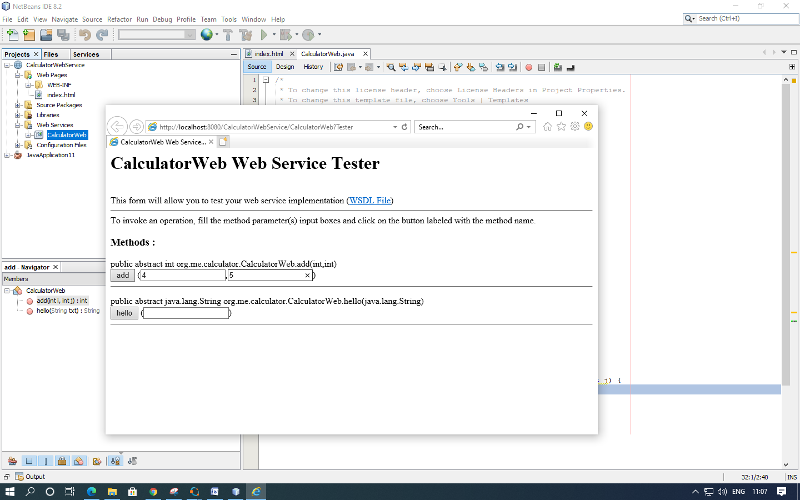

5. The sum of the two numbers is displayed:

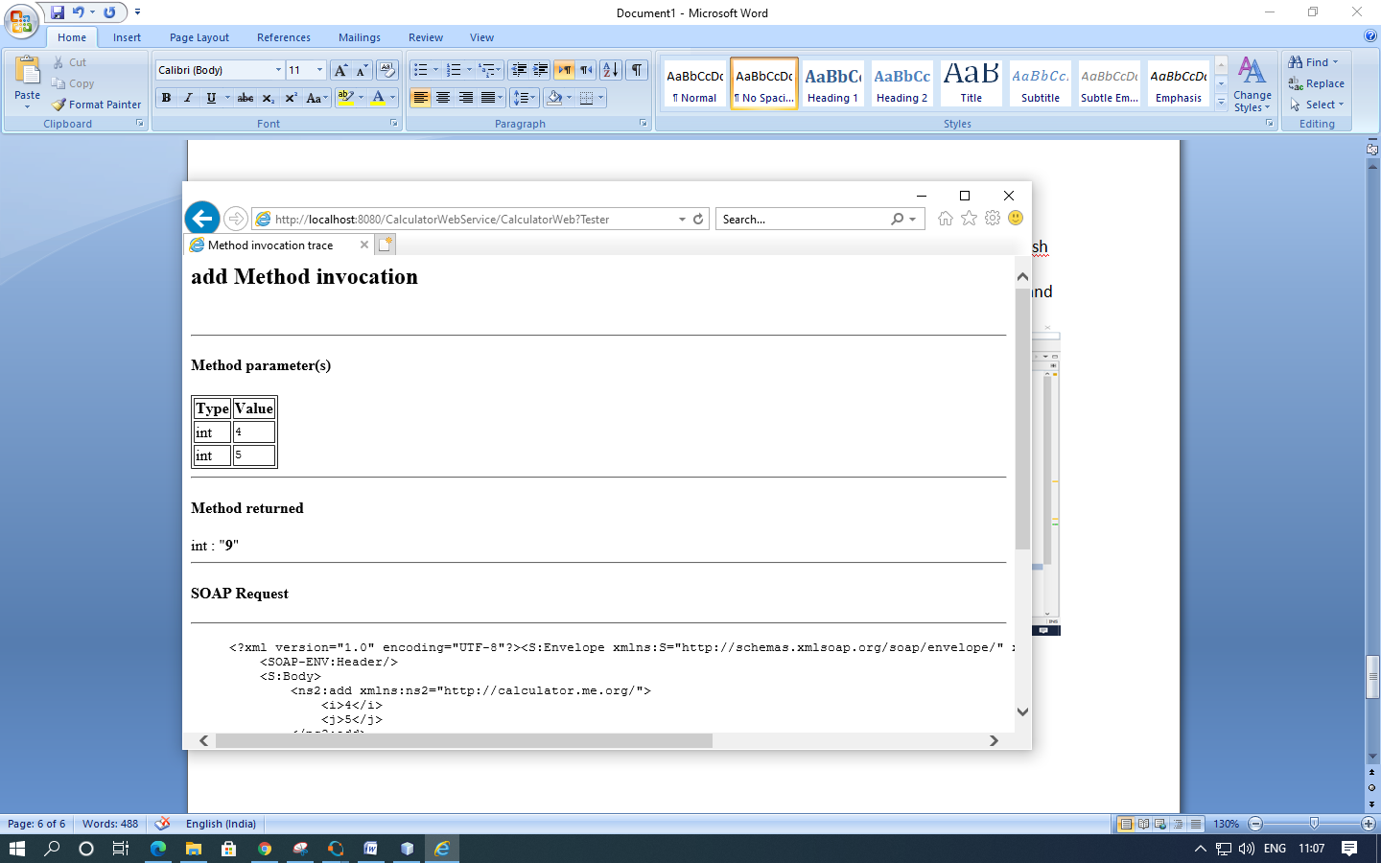

**4. Consuming the Web Service :**

Now that you have deployed the web service, you need to create a client to make use of the web service's add method.

**1. Client: Java Class in Java SE Application**

1. Choose File > New Project. Select Java Application from the Java category.

Name the project “CalculatorWeb_Client_Application”. Leave Create Main Class selected and accept all other default settings. Click Finish.

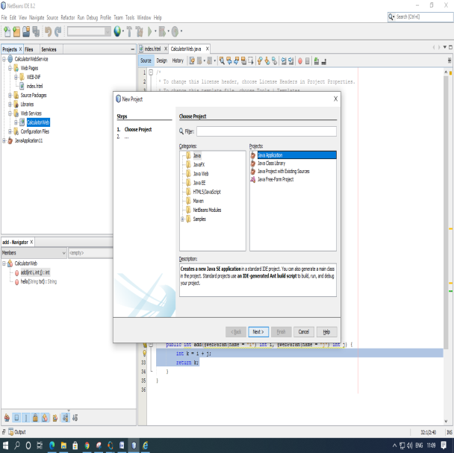 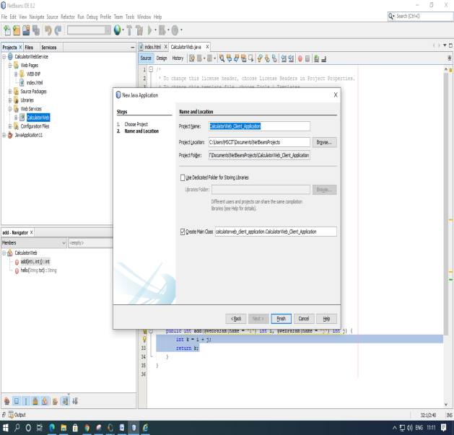

2. Right-click the “CalculatorWeb_Client_Application” node and choose New > Web Service Client. The New Web Service Client wizard opens.

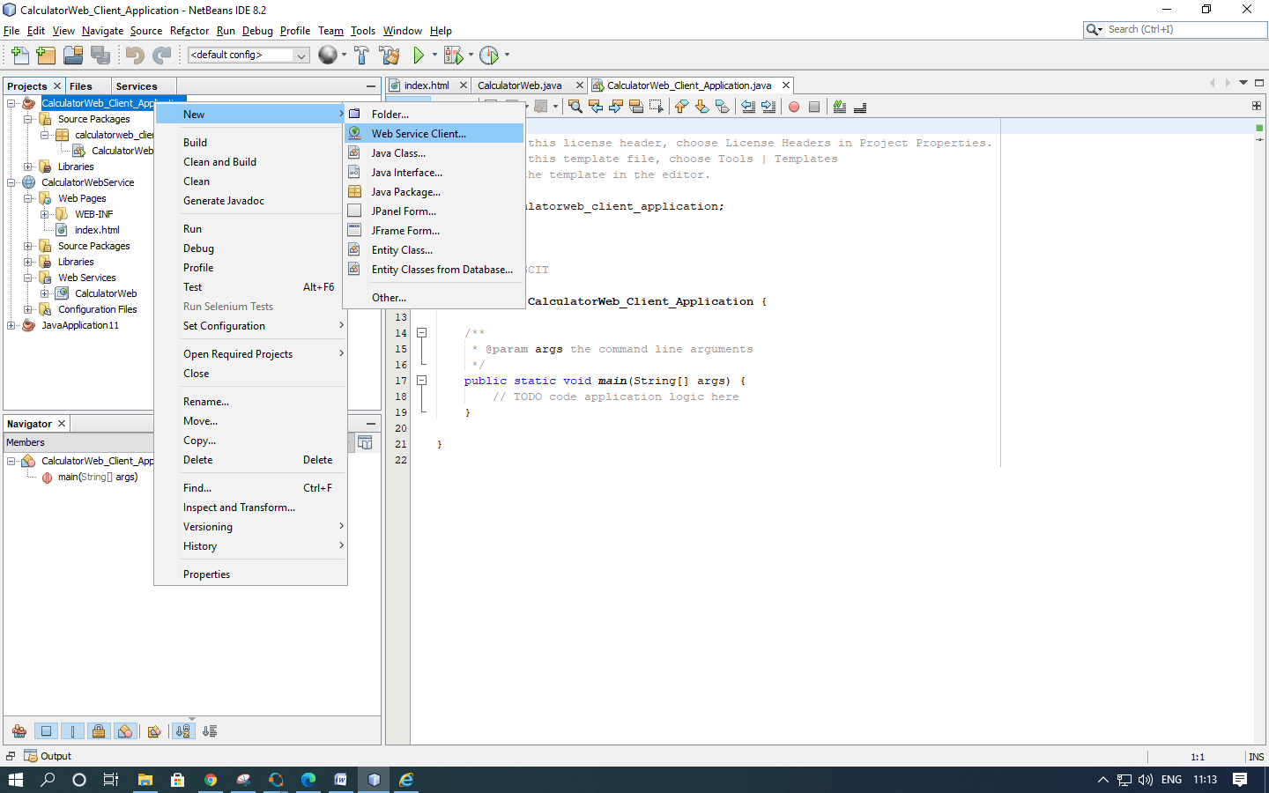

3. Select Project as the WSDL source. Click Browse. Browse to the “CalculatorWeb” web service in the “CalculatorWebService” project. When you have selected the web service, click OK.

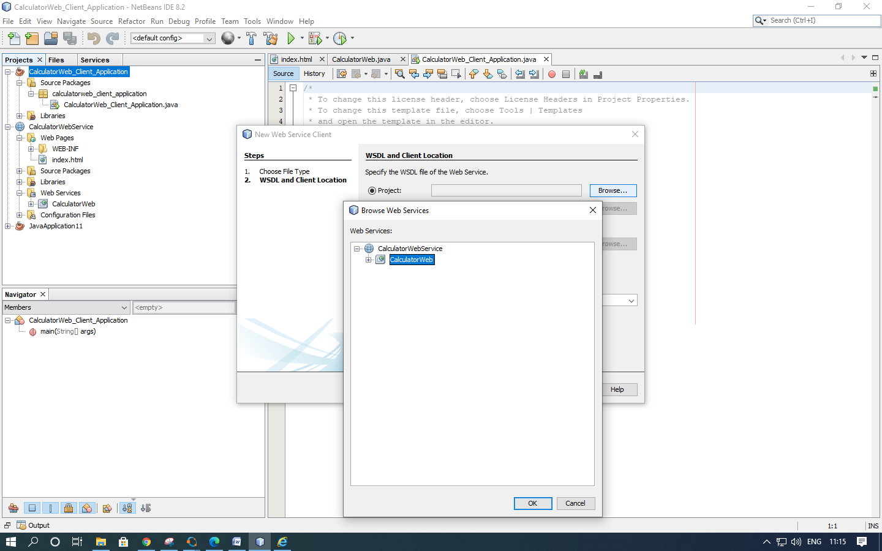

4. Do not select a package name. Leave this field empty. Leave the other settings at default and click Finish.

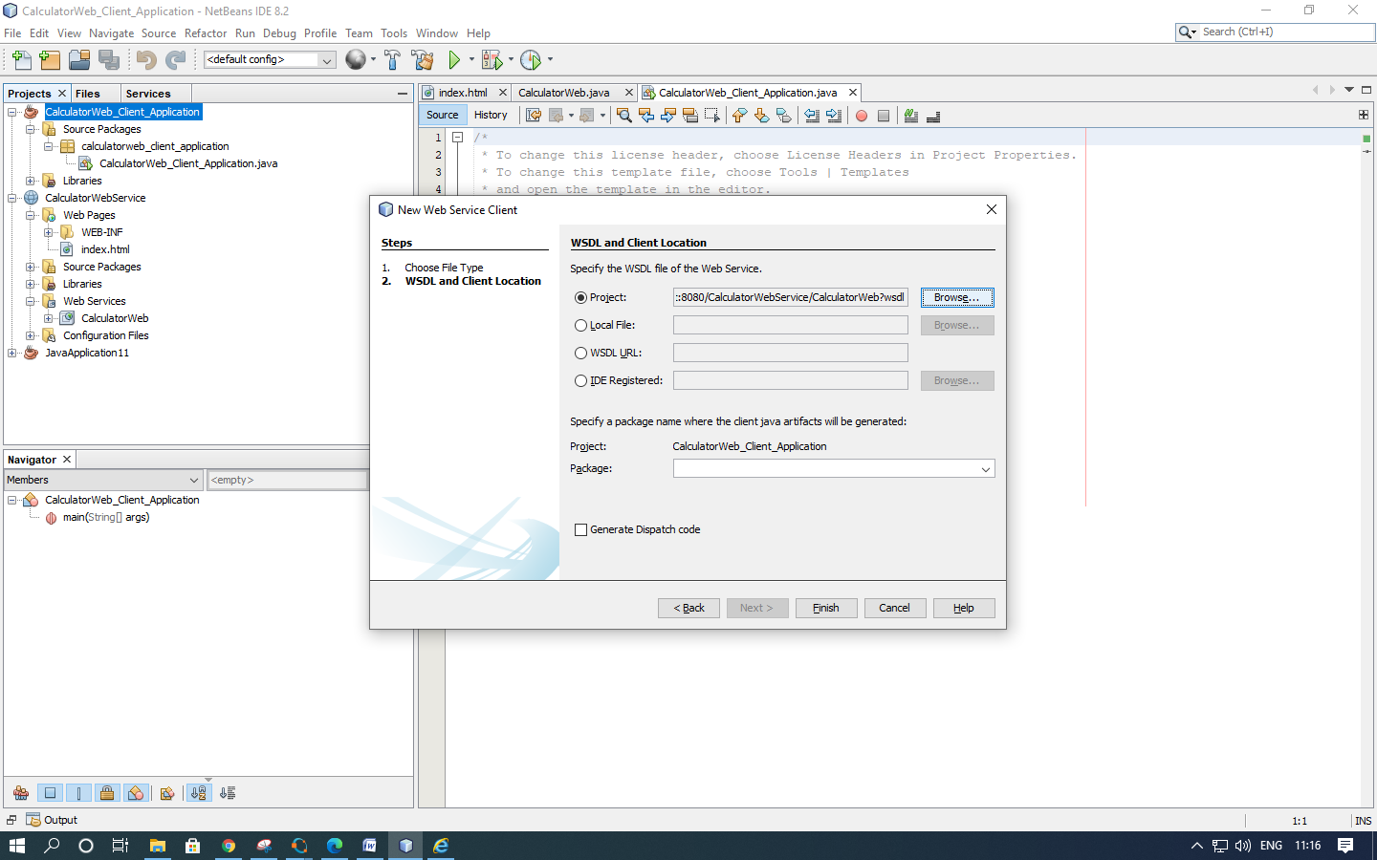

5. The Projects window displays the new web service client, with a node for the add method that you created:

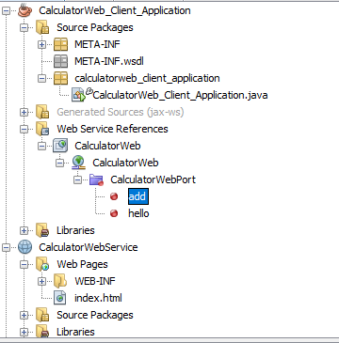

6. Double-click your main class so that it opens in the Source Editor. Drag the add node below the main() method.

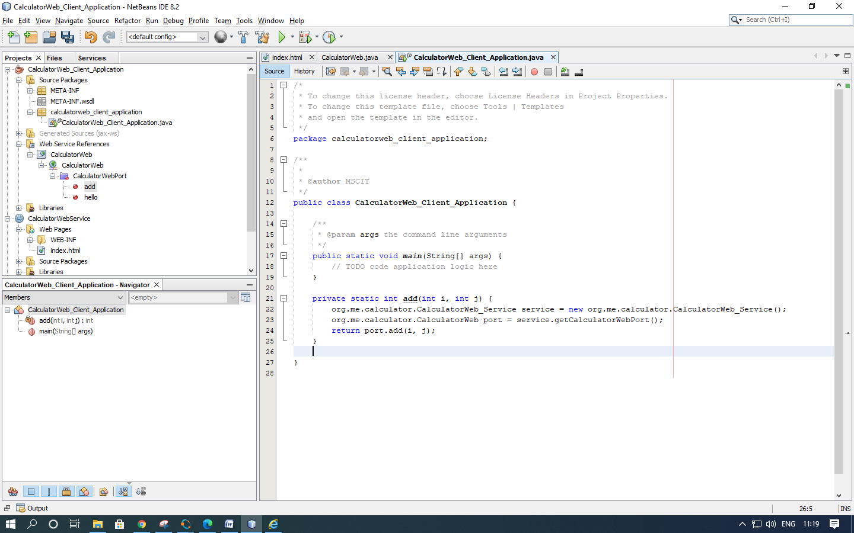

7. In the main() method body, replace the TODO comment with code that initializes values for i and j, calls add(), and prints the result.

try

{

int i = 3;

int j = 4;

int result = add(i, j);

System.out.println("Result = " + result);

}

catch (Exception ex)

{

System.out.println("Exception: " + ex);

}

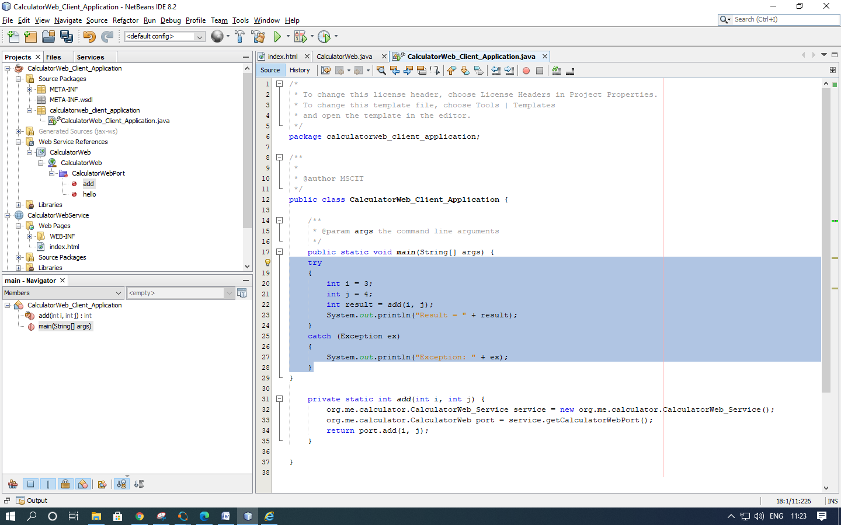

8. Right-click the project node and choose Run.

The Output window now shows the sum:

compile: run: Result = 7 BUILD SUCCESSFUL (total time: 1 second)

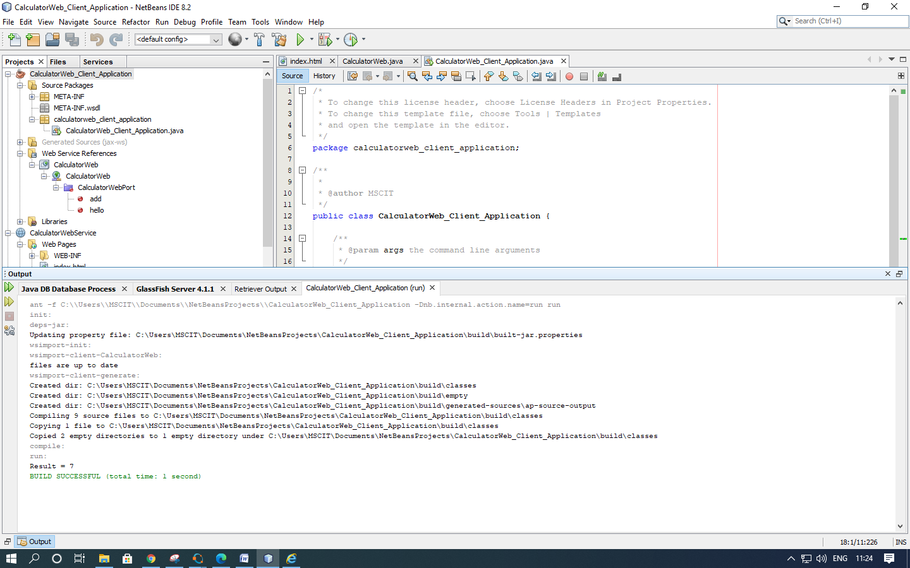

**2. Client : JSP Page in Web Application**

In this section, you create a new web application and then consume the web service in the default JSP page that the Web Application wizard creates.

1.Choose File > New Project. Select Web Application from the Java Web category. Name the project CalculatorWebJSPClient. Click Next and then click Finish.

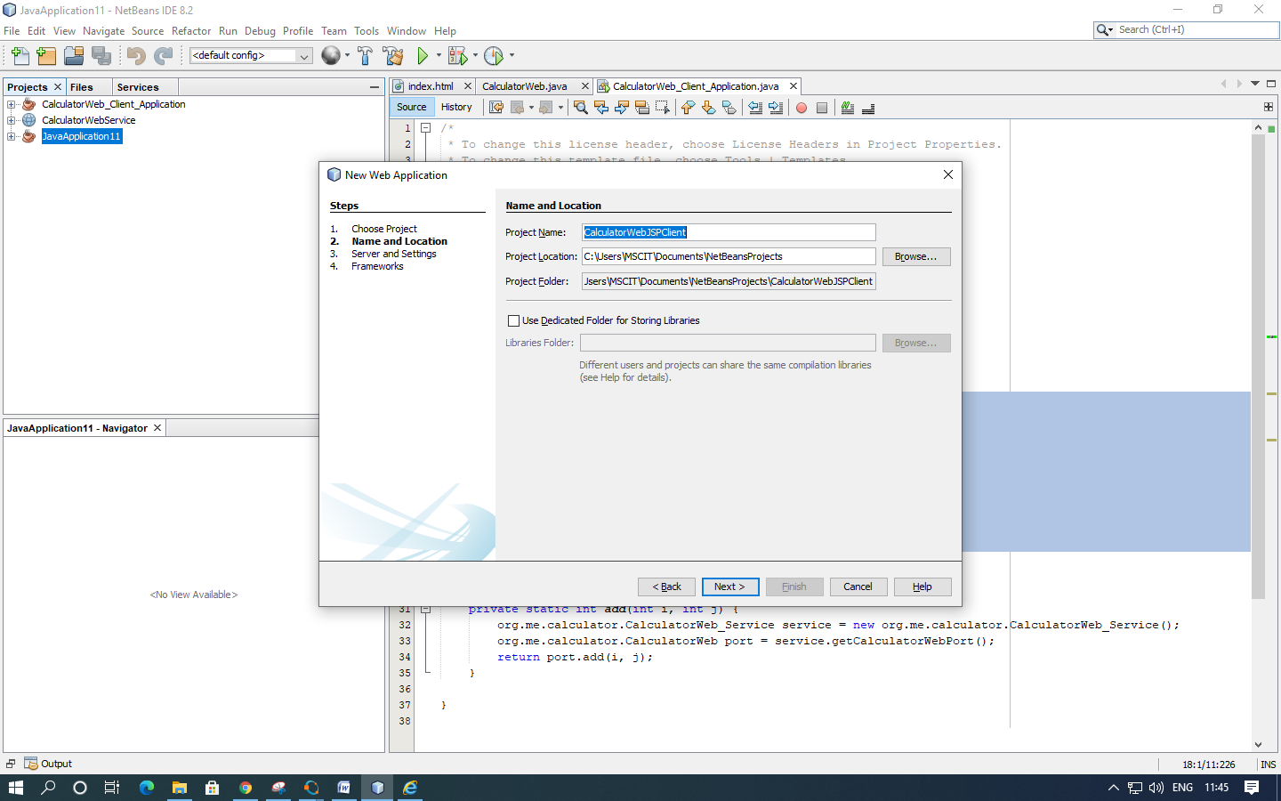

2.Expand the Web Pages node under the project node and delete index.html.

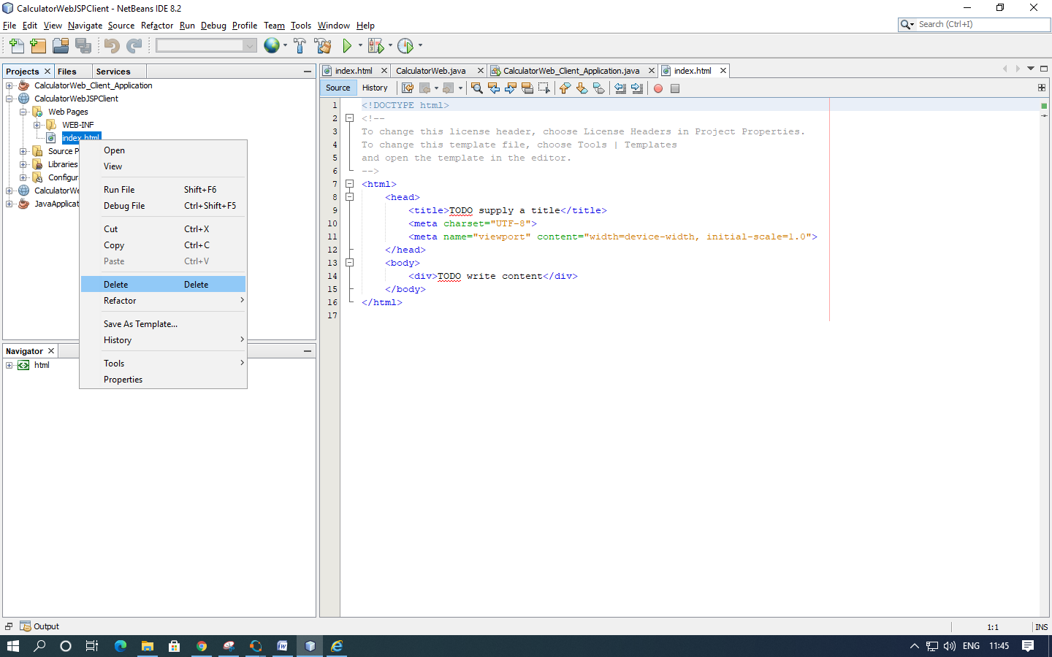

3.Right-click the Web Pages node and choose New > JSP in the popup menu.

If JSP is not available in the popup menu, choose New > Other and select JSP in the Web category of the New File wizard.

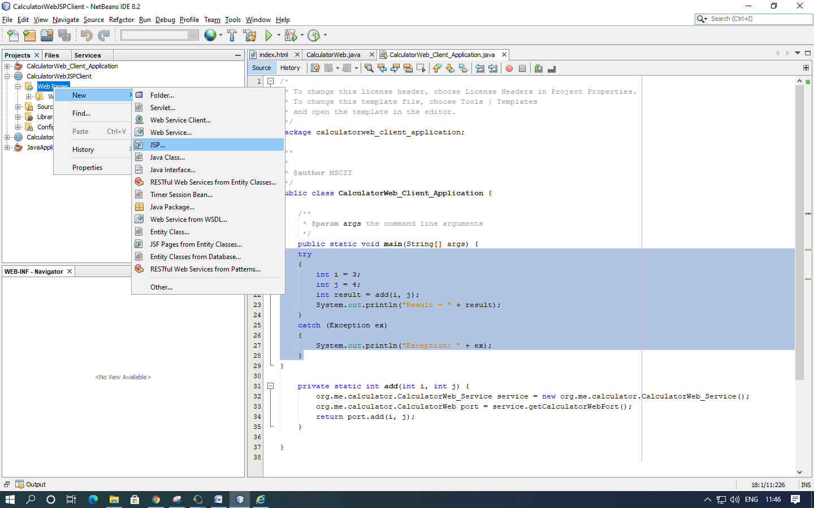

4.Type index for the name of the JSP file in the New File wizard. Click Finish.

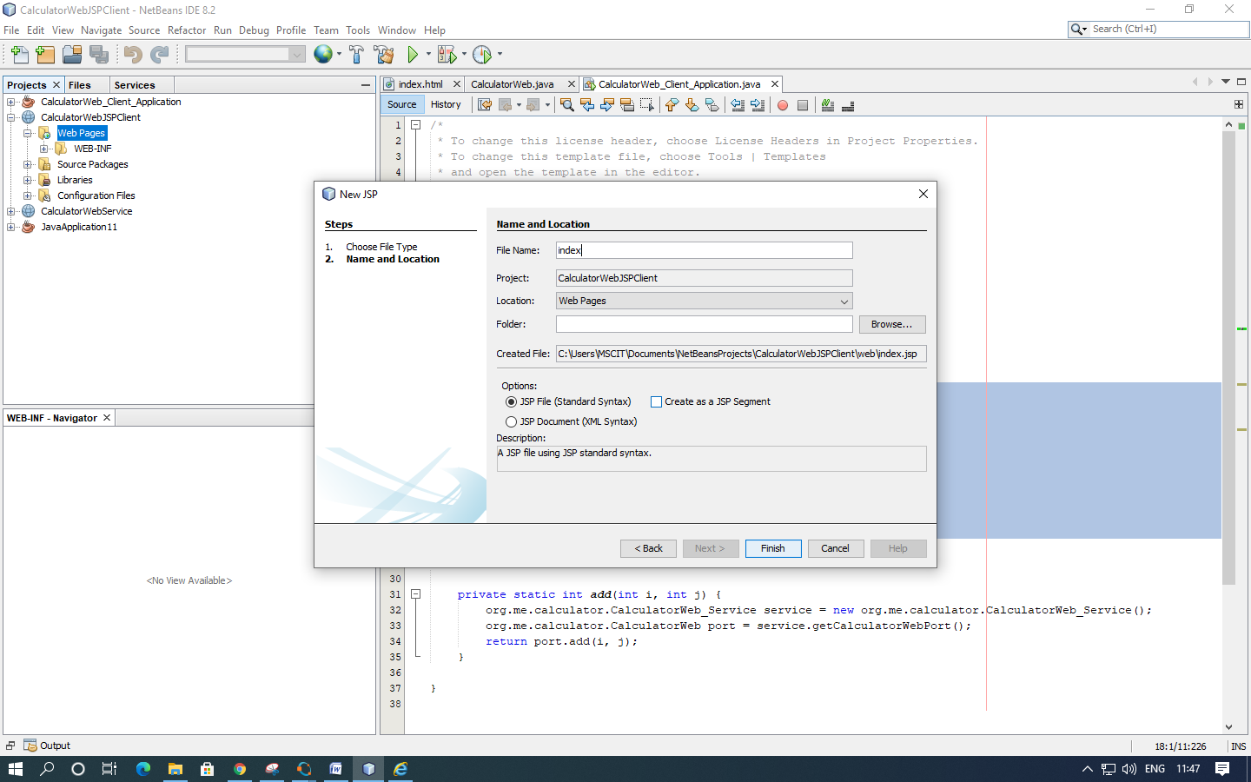

5.Right-click the CalculatorWebJSPClient node and choose New > Web Service Client.

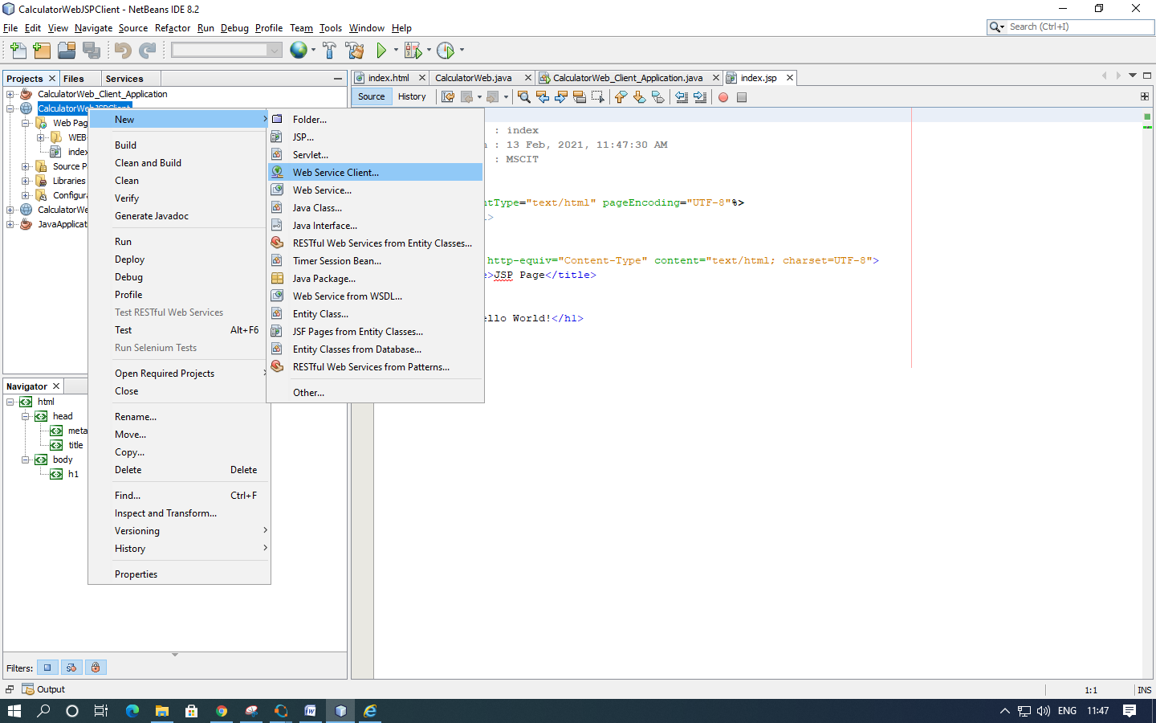

6.Select Project as the WSDL source. Click Browse. Browse to the CalculatorWeb web service in the CalculatorWebService project. When you have selected the web service, click OK.

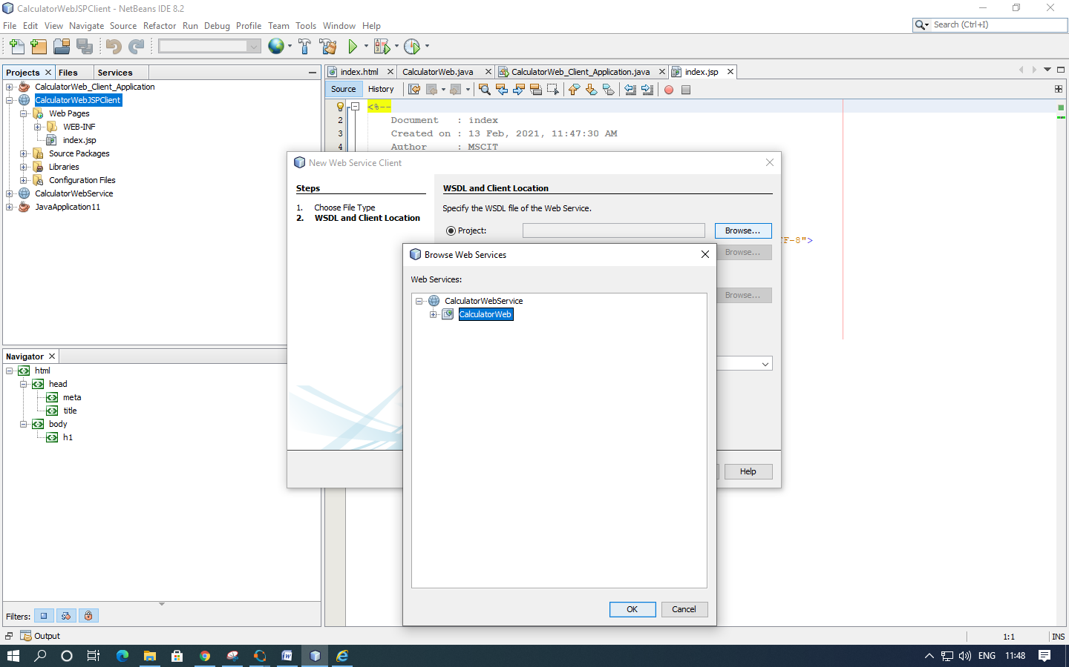

7.Do not select a package name. Leave this field empty.

Leave the other settings at default and click Finish.

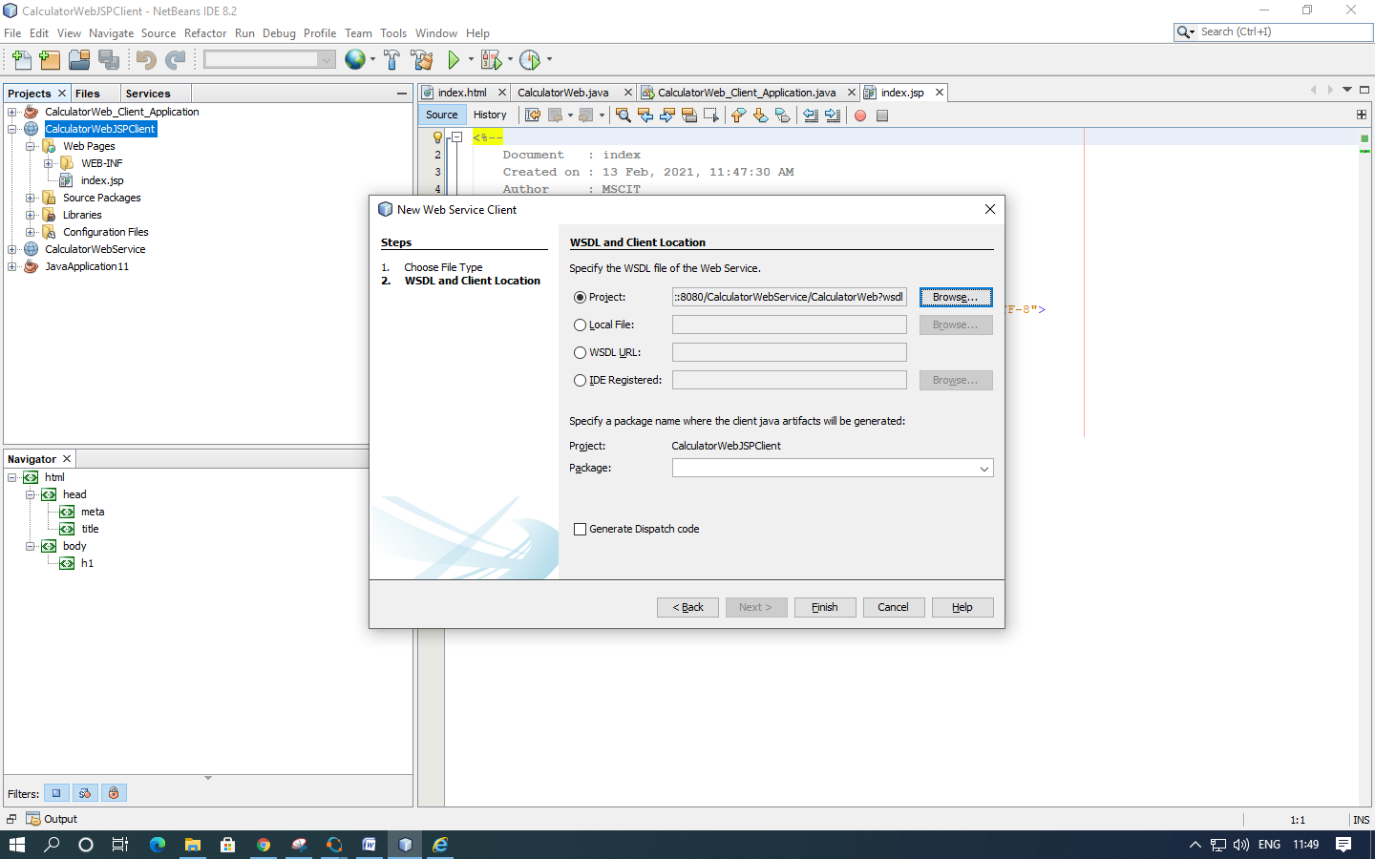

8.The Projects window displays the new web service client, as shown below:

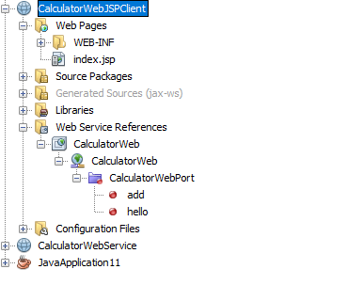

9.In the Web Service References node, expand the node that represents the web service. The add operation, which you will invoke from the client, is now exposed.

Drag the add operation to the client's index.jsp page, and drop it below the H1 tags. The code for invoking the service's operation is now generated in the index.jsp page, as you can see here:

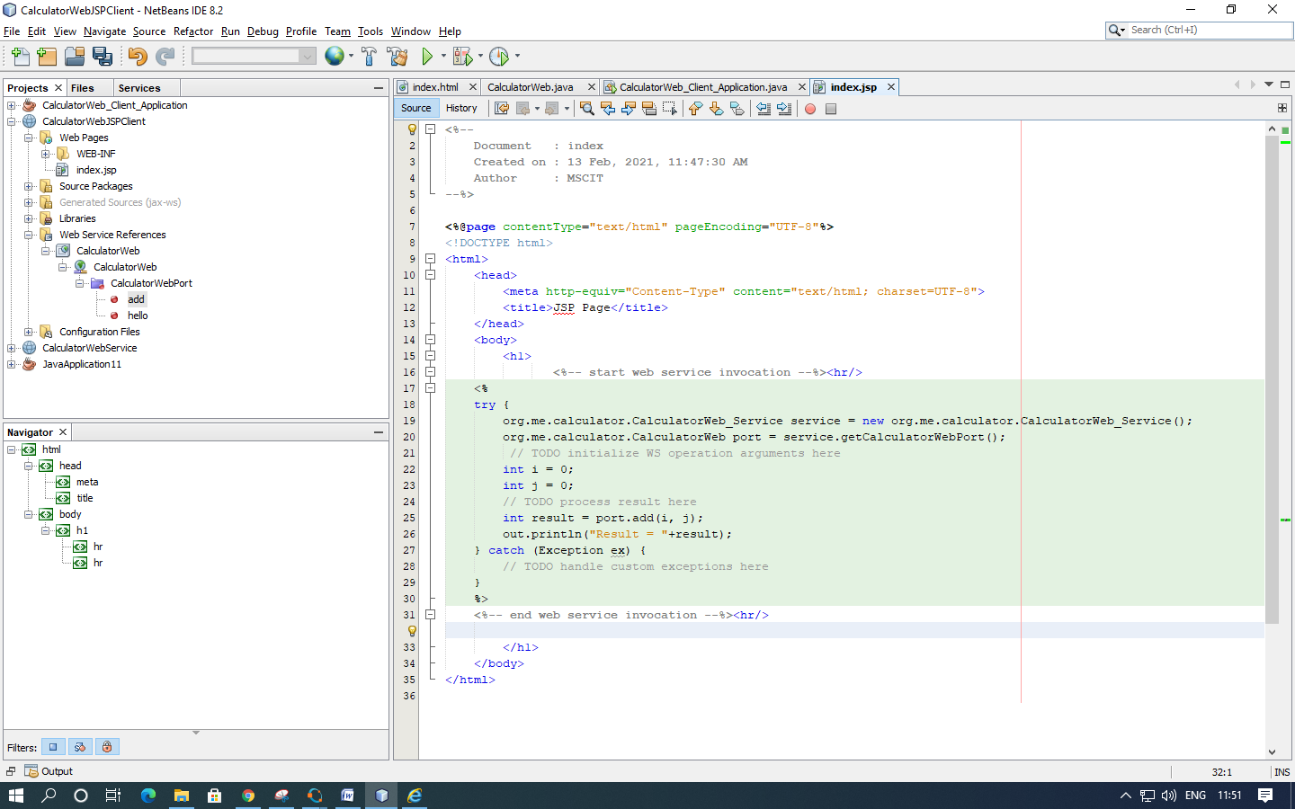

10.Change the value for i and j from 0 to other integers, such as 3 and 4. Replace the commented out TODO line in the catch block with out.println("exception" + ex);

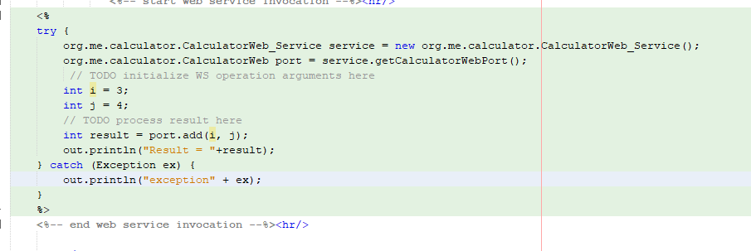

11.Right-click the project node and choose Run.

The server starts, if it wasn't running already. The application is built and deployed, and the browser opens, displaying the calculation result:

